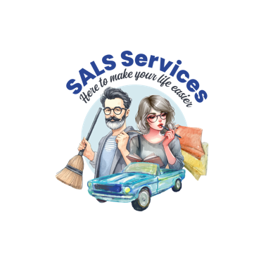
Terms of Business
Scope of Services:
- Cleaning and Home Services
- Concierge Services
- Senior Care Services
- Vacation Services
- Business Support Services

Data Collection and Usage:
- Personal Information: We collect personal information such as name, contact details, address, and payment information to provide our services effectively.
- Service Preferences: Details about your specific service preferences and requirements to tailor our offerings to meet your needs.
- Special Categories of Data: Health information or other sensitive data relevant to the provision of senior care services.
Data Storage and Protection:
- Secure Storage: All client data is stored securely using security protocols to prevent unauthorized access.
- Access Control: Access to client data is restricted to authorized personnel who need the information to perform their job duties.
Data Sharing and Disclosure:
- Third-Party Service Providers: We may share your information with trusted third-party service providers who assist us in delivering our services. These providers are bound by confidentiality agreements and data protection regulations.
- Legal Requirements: We may disclose your information if required by law or in response to valid legal requests.

Client Rights:
- Access: You have the right to request access to the personal information we hold about you.
- Correction: You have the right to request corrections to any inaccurate or incomplete information.
- Deletion: You have the right to request the deletion of your personal information, subject to certain legal and contractual limitations.
- Objection: You have the right to object to the processing of your personal information under certain circumstances.
Retention Policy:
- Duration: We retain client data for as long as necessary to fulfil the purposes for which it was collected, including any legal, accounting, or reporting requirements.
- Disposal: When data is no longer needed, we dispose of it securely to prevent unauthorized access.
Changes to Terms:
- Updates: We may update these terms from time to time. Significant changes will be communicated to clients through appropriate channels.
Contact Information: For any questions or concerns regarding these terms or your personal data, please contact us at: contact@sals-services.co.uk.
Client Consent: By using our services, you consent to the collection, use, and storage of your personal information as outlined in these terms.

These terms ensure that SALS Services handles client data responsibly and transparently, prioritizing privacy and security in all aspects of our service delivery.
Top of Form
Bottom of Form

Interpretation & General:

Liability:

- SALS Services shall use all its reasonable endeavors to provide the services using reasonable care and skill as far as reasonably possible, in accordance with the Clients request & instructions.

- SALS Services shall have no liability to the Client for any loss, damage, costs, expenses or other claims for compensation arising from requests or instructions supplied by the Client, which are inaccurate, incomplete or incorrect, or arising from their late arrival or non-arrival or any other fault of the Client.

- The Client shall not request SALS Services to run errands, which are immoral or unlawful in nature, equally SALS Services reserves the right to deny any service that is out of SALS Services realm of expertise, is unsafe or illegal.

- SALS Services will endeavor to carry out all tasks in a timely manner, however, SALS Services shall not be responsible for any delay in performing or any failure to services provided, if the delay or failure was due to any cause beyond SALS Services control.

Payments:

Payments can be made via:

- Card Payment – debit and credit card
- Cash
- BACS – Bank Transfer

Bank Details as follows:

Natwest
Business Name – SALS Services
Account Number
Sort Code

As a rule, all payments for work and services carried out, are expected to be paid on the same day, however payment terms will be discussed with the Client’s prior to any works being carried out, to discuss the most convenient method and timescales suited to both parties. This will be dependent on if the work is a one off or on a regular basis.

For errands that in incur purchasing goods, budget + payment terms will have been discussed prior to the errands being carried out.
If failure of payments for goods is not made in line with agreed payment terms, then formal action will be taken for costs incurred.

